Fossil Identification Lab/Earth Science/Mrs. Cohn
Name:______________________________________________ Block:_____________
What is a fossil? Fossils are the remains or traces of plants and animals that lived long ago. ... Most fossils are found in earth that once lay underwater. They usually formed from the hard parts—such as shells or bones—of living things. Fossils can be made via five different methods of preservation.
- Permineralzation- when dissolved minerals carried by ground water fill the cellular spaces of plants and animals. The dissolved minerals crystalize over time when the water becomes supersaturated, and produce rocks in the shape of the original animal or plant, called a cast. Examples include petrified wood, and teeth, and whole bone fragments.
- Cast Method- flowing water removes all the original tissues and bone from the animal settled on the ground, and an impression is left in the sediment, called a mold. Minerals fill in the mold, recreating the original shape of the organism called a cast. These are commonly found in marine invertebrates like shells.
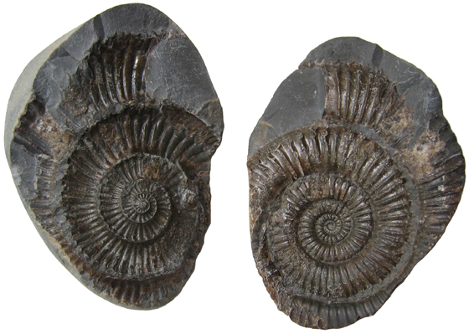
- Amber- organisms become trapped n tree resin that hardens into amber after the tree is buried underground. Most of the time we find insects, pollen, frogs, even small lizards preserved this way.
- Trace fossils Remnants- record the activity of an organism. Nests, burrows, imprints of leaves, feces, footprints. They are still created in the same way that fossils are created in the cast method.
- Preserved remains- record intact remains of animals such as skin, muscle, bone, hair and organs this is when an entire organism becomes encased in materials such as ice, ash, or buried peat. This is rarer, but this is how woolly mammoths were discovered.
Mold vs. Cast
Pre Lab Questions (requires the use of a reference table):
- A paleontologist finds a fossil impression of a trilobite
  - Have they discovered a cast or a mold?

  - Without identifying the specific species of trilobite, the paleontologist can make a solid decision that this strata must be older than which numerical age?

  - If the paleontologist discovered that he was looking at the species, Cryptolithus, he could then estimate the age of the strata to be __________________ million years old.

- Why wouldn’t a soft-bodied organism be preserved via the cast method?

- A paleontologist finds the preserved tooth of a Coelophysis Dinosaur.
  - Have they discovered a cast or mold?

  - Which method of fossilization likely formed this fossil?

  - The paleontologist could infer that the strata this tooth was found in, dates back to _________________ million years ago, during the _______________ time period.
Objective: To observe and accurately identify 12 different types of fossils, then using the fossil at hand, identify which type of preservation was used, and if you are looking at a cast OR a mold.
Fossil Letter and quick sketch | Organism Name | Cast or Mold? | Method of Formation
A

B

C

D

E

F

G

H

J

K

L

M

